**Yesha shah **

**AU2010173**

**Lab report 3**

**Introduction:**

Among the most crucial areas of study in psychology is attention. Once we examine attention, particularly visual attention, the visual search method proves to be very helpful because it allows us to gauge visual attention while also being a completely separate area of study. Visual, cognitive, and sensory procedures all play a role in visual search. The demands on your attention can shift if you modify the searching task. Attention alters visual search by selecting and restricting the data available at various levels of processing. By focusing on the intersection of attention and search, a reasonably organized window into the vast domain of selective attention events is provided. The benefits of divided attention and selective attention, correspondingly, are best shown by the effects of set size (the quantity of stimuli in a visual) and the consequences of looping subsets of stimuli inside the showcase. Research on the ability to deliberately find a focus or item among a complex variety of stimuli has been ongoing over the past 40 years. Visual search is employed while selecting an item from a grocery store shelf, when animals are searching for food among piles of leaves, when trying to locate a friend in a busy environment, and in other real-world scenarios.

**Method:**

The observer has to choose between a bunch of distractors and find a ‘T’ among them by clicking on them by a mouse or a keyboard response.

* A cross fixation is added in the center for 1 second.
* A text component for ‘T’ target is added for an infinite time frame.
* A text component for the distractor which is a ‘L’ text component is added for an infinite time frame.
* The text component for the distractor is replaced with lines of codes, in the begin routine and the end routine section of the code.

if random() greater than 0.5:

num_distr = 10

thisExp.addData('num_distr', num_distr)

else:

num_distr = 5

thisExp.addData('num_distr', num_distr)

distractors = []

for i in range(num_distr):

distr = visual.TextStim(win=win, name='distr',

text='L',

font='Open Sans',

pos=(random()-0.5, random()-0.5), height=0.1, wrapWidth=None, ori=randint(0,360),

color='white', colorSpace='rgb', opacity=None,

languageStyle='LTR',

depth=0.0);

distractors.append(distr)

for distr in distractors:

distr.setAutoDraw(True)

* Make the position of the ‘T’ random.
* Add a mouse response with which the observer can select the ‘T’ for the experiment.
* Change every time too, ‘until response’ time frame.
* Addition of a loop to the whole psychopy program.
* The program is set for 200 repetitions.

**Result:**

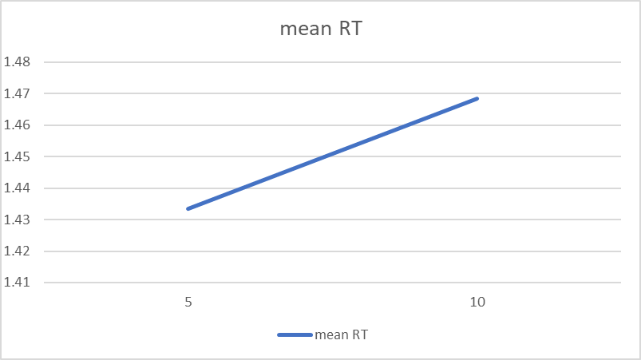

slope= 0.007005

**Discussion:**

The mean RT increases as the set size increases. This indicates that more attention is required to detect the target as the distractors increase.

**Git hub link:**